Java Date and Time
- The java.time, java.util, java.sql and java.text packages contains classes for representing date and time
- Now let’s see java.util.Date class
- The java.util.Date class represents date and time in java.
- It provides constructors and methods to deal with date and time in java.
- The java.util.Date class implements Serializable, Cloneable and Comparable<Date> interface.
- It is inherited by java.sql.Date, java.sql.Time and java.sql.Timestamp interfaces.
- Date implements Comparable<Date> and so two dates can be compared directly with the compareTo method. ...
- After Calendar class, most of the constructors and methods of java.util.Date class has been deprecated.
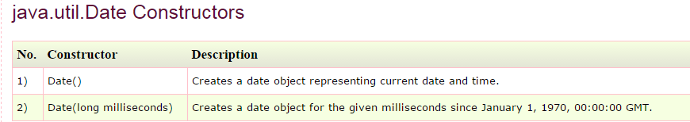
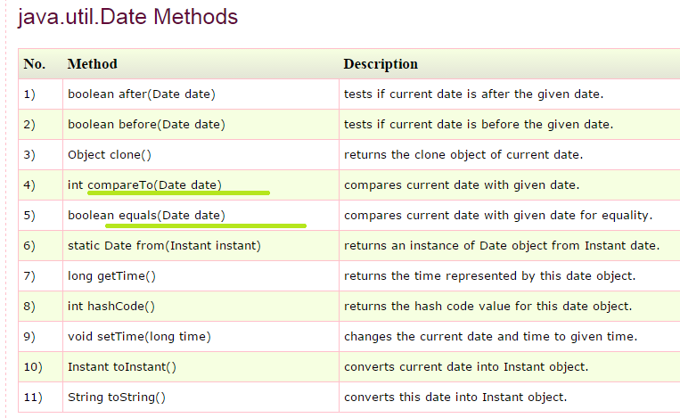
- System.currentTimeMillis();
- Now let’s See java.sql.Date class ➔
- The java.sql.Date class represents only date in java.
- The java.sql.Date instance is widely used in JDBC because it represents the date that can be stored in database.
- 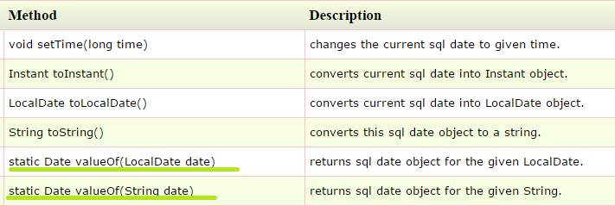
- Now let’s See the java.util.Calendar class
- Java Calendar class is an abstract class
- Syntax for Declaring a calendar class 
- Now let’s see few methods of calendar class➔ NOTE I HAVE NOT COVERED CALENDAR FULLY ONCE UR STABLE IN BASIC THEN WE WILL LOOK INTO IT

- 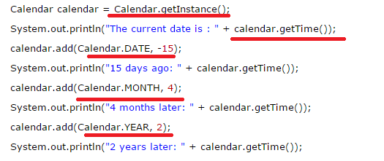

- 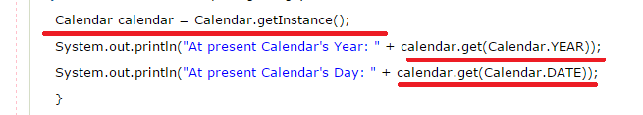
- 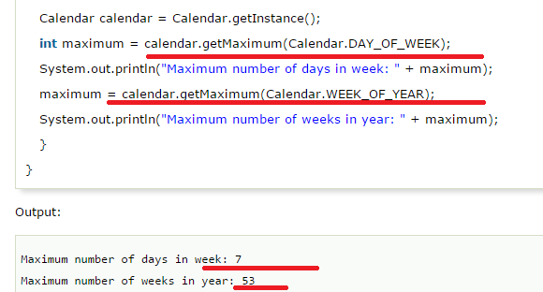

----------------------------------------------------------------------------------------------------------------

- 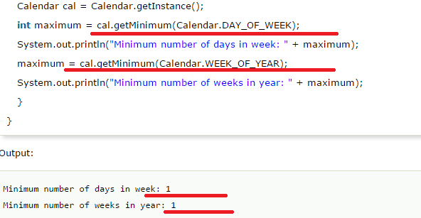

- Now Let’s See the GregorianCalendar in Java
- Class java.util.GregorianCalendar. GregorianCalendar is a concrete subclass of Calendar and provides the standard calendar used by most of the world. The standard (Gregorian) calendar has 2 eras, BC and AD.
- Syntax ➔ later

Java Date Format
- There are two classes for formatting date in java: DateFormat and SimpleDateFormat.
- The DateFormat class is an abstract class.
- java.text.Format is the parent class and java.text.SimpleDateFormat is the subclass of java.text.DateFormat class.
- The java.text.DateFormat class provides various methods to format and parse date
- In java, converting date into string is called formatting and vice-versa parsing.
- 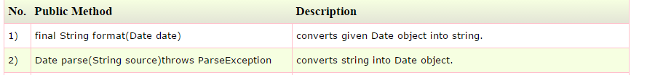

NOTE ➔ IN DATEFORMAT CLASS I HAD JUST COVERED ABOVE 2 METHODS apart FROM THIS 2 THER ARE MORE METHODS AND FIELDS PRESENT IN THE DAREFORMAT CLASS SEE THOSE LATER

Java SimpleDateFormat
- The SimpleDateFormat is a concrete class for formatting and parsing date which inherits java.text.DateFormat class.

Note: M (capital M) represents month and m (small m) represents minute in java.
- Ms ➔ It has few formatters like Y, y m, H, m,s etc… which we will see later

- Syntax for creating date element in Map ➔
- Wanted to know how to add a date object in the above map

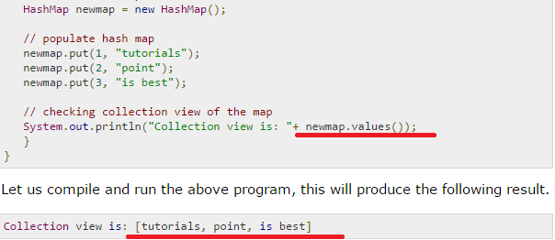

Array of Dates in Java
- 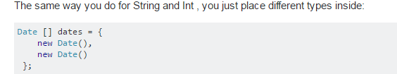
- Or
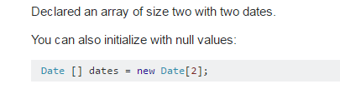
- Or
